TETRIS PROJECT

Student Name: Emre Gülbaş

Student ID: 24040102016

<https://github.com/Emre-Gulbas/TetrisJavaFX>

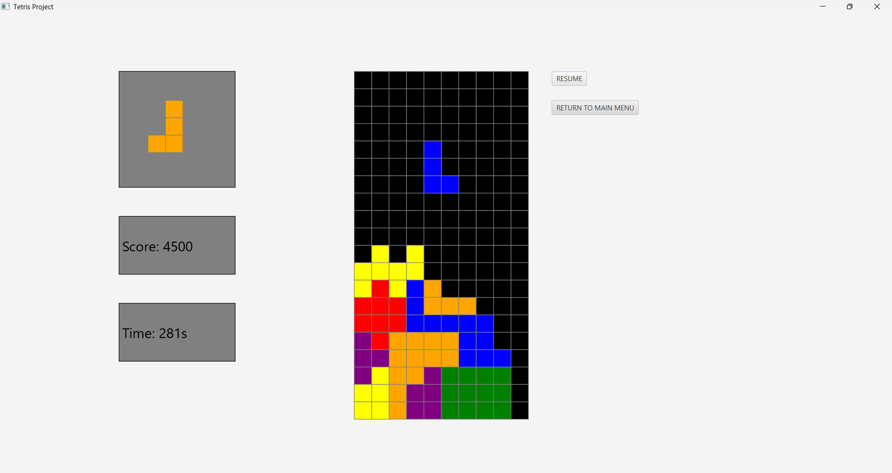

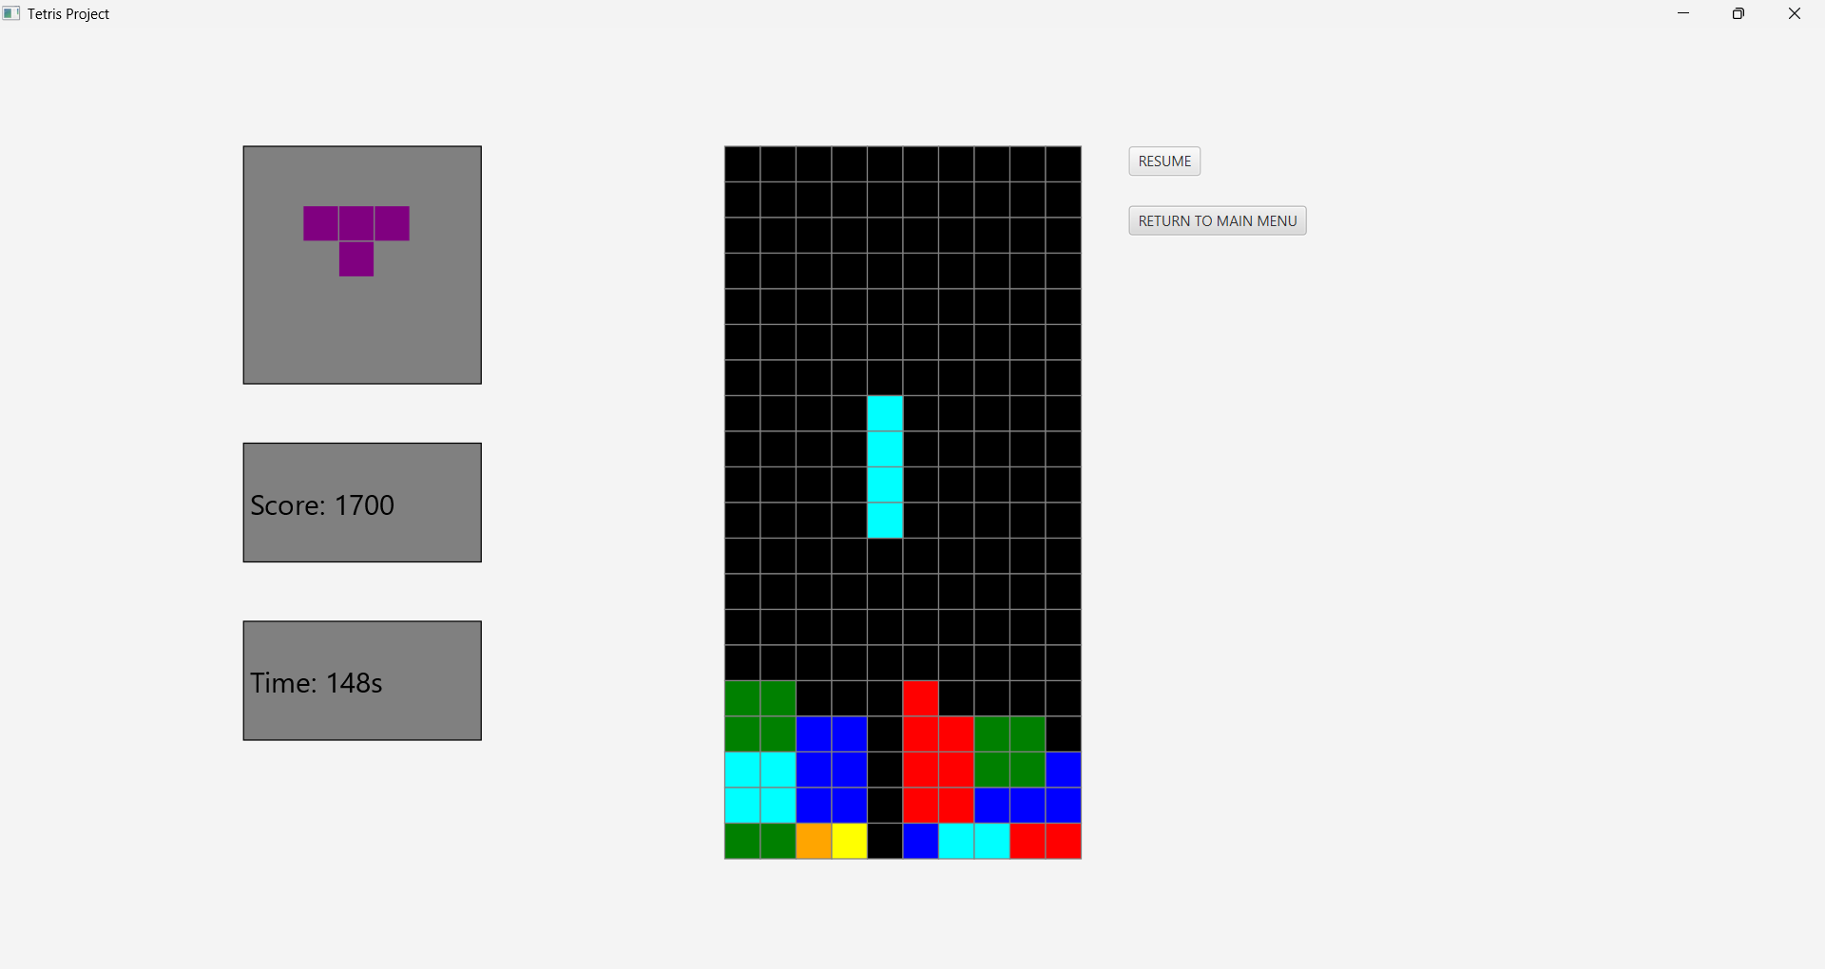

A Tetris game made in JavaFX. This project has many parts that can be seen in similar games, but this project also has a score system and a timer that is saved locally, a preview box, as well as a leaderboard where you can see your performances. Other than these, there is also a two-player mode where you can race your friends.

|  |  |  |
| --- | --- | --- |
| **Feature** | **Successfully realized (Yes or No)** | **Source code file names** |
| Basic functionality | All Basic Functions in Tetris. Yes |  |
| Authentication | Login & Register system. Yes | LoginAndRegister.java  SessionProfile.java |
| File processing | Login.txt and Score.txt. Yes | LocalScores.java  AllEntries.java |
| **Additional features (if any):** |  |  |
| 1st Additional feature | Two Player Gamemode. Yes | GameTwoPlayer.java |
| 2nd Additional feature | Preview Box for the next block. Yes | GameOnePlayer.java GameTwoPlayer.java |
| 3rd Additional feature | Timer and Score system. Yes | GameOnePlayer.java GameTwoPlayer.java |
| 4th Additional feature | Leaderboard. Yes | LocalScores.java |

References:

<https://www.w3resource.com/java-exercises/javafx/javafx-user-interface-components-exercise-5.php>, <https://stackoverflow.com/questions/64648664/javafx-read-data-from-text-file-and-paste-it-to-the-right-place>, [https://stackoverflow.com/questions/24565539/in-need-of-javafx-help-writing-to-a-txt-file,](https://stackoverflow.com/questions/24565539/in-need-of-javafx-help-writing-to-a-txt-file,%20for%20LoginAndRegister.java) for LoginAndRegister.java.

References:

<https://liveexample.pearsoncmg.com/html/AddNewRowDemo.html> and <https://www.youtube.com/watch?v=Pnaqn6GOyzU>, for LocalScores.java.

ChatGPT generated SessionProfile.java and AllEntries.java, newNextPiece, getType, canRotate, canMove, canMoveDown, removeFromGroup, shiftRowsDown and a little part of the lockToGrid method in GameOnePlayer.java, and first if in leaderboard scene in LocalScores.